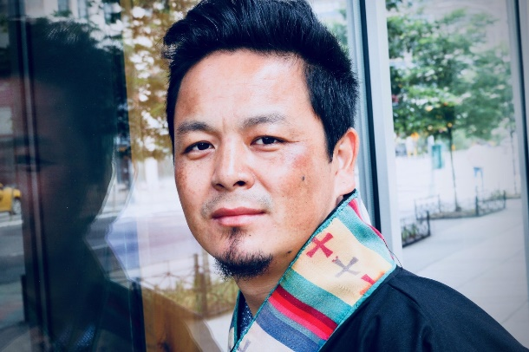
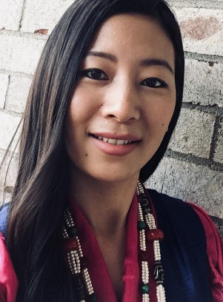
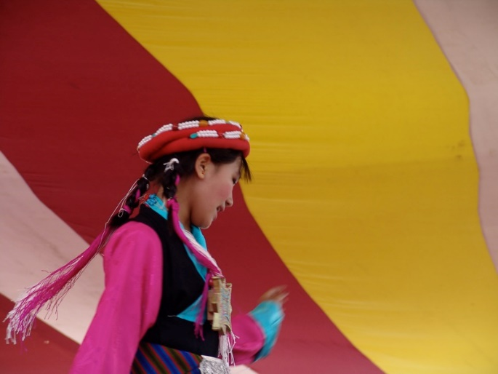

About the Tibetan Dancers and Dances to be Performed

Tashi Sholpa - (Good Luck Dance) - Tashi Shoelpa is the oldest opera company in Tibet. This dance
originally appeared in a dream of the Great 5th Dalai Lama in 1645 and was performed during the
enthronement ceremony of Fifth Dalai Lama. The performer wearing the white-beard mask represents
Saint Thantong Gyalpo, the founder of Lhamo/Tibetan opera, who reputedly lived for 140
years and also symbolizes long life and good health. Lhamo/Tibetan opera conveys the teachings of
Lord Buddha through historical reenactment. The purpose of this very dance is to bring
good luck and prosperities

Dranyen Shapdro - (The Dance of the Lute Player) The lute player perform
a variety of quick foot-stepping dances to the rapid catchy music of the Tibetan
lute. This dance is typical of Lhasa, the capital of Tibet. The songs, which
accompany the music and dancing, are still very popular among the Tibetan.

Tenzin Younden is a Tibetan musician, dancer and an actor currently living in Boston, Massachusetts. He
is best known for his character Richard in the film “Richard Gere is my hero” and Tenzin in the film
“Semshook”. At the age of 12 he was selected as a child artist at Tipa (Tibetan Institute of Performing
Arts) . For 16 years at Tipa, he has been working in the field of Arts, particularly on traditional Tibetan
music, dance and opera. He had travelled to many countries in Europe, Asia and Australia to showcase
Tibet’s rich cultural performing arts. He has also given several workshops on Tibetan performing arts to
many Tibetans and non-Tibetans. He takes great pride in being able to represent his country by
performing its unique and centuries-old traditional music and dances.

Tenzin Chodon is a Tibetan artist and actor currently living in Boston MA. In her sixteen years of residency at Tibetan Institute of Performing arts. She studied traditional Tibetan dances, music and operas. She became a leading dancer and musician and toured with the Institute in many countries to showcase Tibet’s rich cultural performing arts. Currently she is an artist of Dhangsang Lughar Tibetan music group. She is also well known for her leading role in the film “Richard Gere is my hero” and “Semshook”.

